SurgeCity Overview

The following is a proposal for a city-builder strategy game, playable on Windows PCs. SurgeCity will be an isometric resource-management game, inspired by franchises such as SimCity and Cities: Skylines. Whereas those games are full city-builders, this game is focused on flood events, defenses, and all the choices and dilemmas that come with them. The stated purpose of the game is research and education, and two particular features must be woven in for those purposes. The first research feature is a “GIS reader” that will turn GIS maps into in-game maps. The second is AI-powered agents that will fill the roles of factions as well as judging. However, the philosophy we will follow is to make the game fun with engaging reward systems, gameplay loops, and charming 16-bit graphics, only implementing the research features with game design philosophy in mind.

Game Design
Overview:
SurgeCity is an isometric city-builder game in which the player fills the role of a city manager (some mixture of mayor and various committees). The game will be divided into levels closely modeled on real-life flood-prone regions and even historic flood events. For example, the Louisiana campaign could have the 1995 Flood and 2016 Flood levels. If the “GIS reader” implementation is satisfactory, we may be able to have complete level generation as well.
The challenge of the game lies in: 1) it is impossible to mitigate every aspect of any flood and 2) there are many factions attempting to influence the defense strategies available. Resources and support are limited, so trade-offs must be made.
The player will be able to select three difficulties: easy, medium, and hard. The easy difficulty is a simplified version of the game with forgiving AI and more resources. Medium is slightly simplified, but resources and factions act more realistic. Finally, hard has all the bells and whistles, and the AI and resources are as difficult as in real world scenarios.
The core gameplay loop involves policy phases and crisis phases. They can be thought of as two mini games where the results affect each other. The number of each phase varies, from one of each for tutorials to as many as three each for huge events like hurricanes.
In a policy phase, the player performs turns of implementing change through policies and investments, paying with money and public opinion. Implementing defenses correctly will both make subsequent crisis phases easier and yield immediate returns in public opinion. AI factions will directly comment or complain about certain actions, hinting at high-yield actions (not necessarily the best, however). In all policy phase rounds, there are a limited number of turns before a crisis phase is entered.
Crisis phases represent the real-time response to a flood, somewhat time-dilated to make gameplay sufficiently engaging. Actions (perhaps even time!) available will be heavily dependent on choices in previous phases. The player will have the ability to direct first responders and place defenses in gameplay that much resembles real-time strategy games. In larger flood events, there will be multiple progressively more difficult phases. The last crisis phase is the end of the level, and AI scoring will follow.
After the level, LLM-powered scoring of the player’s performance follows. For non-randomly generated levels, the scoring is decided by comparing the game scenario aftermath with the real-life aftermath as a standard. A scoring scale for randomly generated levels still needs to be determined.

Gameplay
An example playthrough follows (hard difficulty so that we cover everything):
The player is greeted with the splash screen and main menu. They can choose “New Game” or “Load Game”. Load Game simply resumes a previous playthrough. New Game takes them to the Scenario Selection screen.
Scenario Selection
The first thing to greet the player will be a map of the U.S. The player can either select pre-made levels from historically flood-prone areas or use the “level generator”, which is the GIS reader. When browsing levels, a pop-up with information about the flood appears. When a particular level is selected, the pop-up displays a difficulty selection. Once selected, the game begins.
Policy Phase
First, an “advisor NPC” gives the player an information dump—brief so that the player is not bored. Then, the player is in full control. Turns are not timed, but the quantity of them is limited. As stated before, the player’s choices consist primarily of policy selection and defense placement. The player has many utility overlays at his disposal: policy selection, political session, city zoning, drainage, electricity, and flood inundation.
The default view is of the city. Tiles can be selected, displaying their information. A few idle animations will make the city feel alive. This view is largely aesthetic, and the player will often have one or more overlays open.
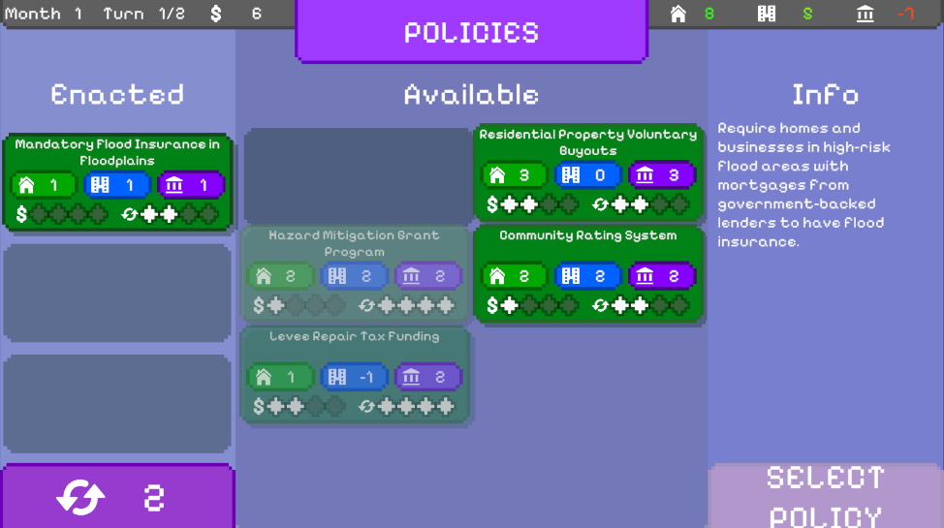
Policy selection is one of the two “main” overlays. The player can view available policies, enacted policies, comprehensive policy information, and available resources. The player is free to enact policies whenever desired, but he is required to enact policies every few turns (depending on the level).
The flood inundation overlay is the other “main” overlay, and it forecasts the water flow during the actual flood crisis event. It is very accurate in terms of predicting flow and water amounts, but it does not account for defenses and other things that will affect the flood. This is likely the player’s go-to overlay for evaluating the situation and strategizing.
The political session overlay screen is highly useful but not strictly necessary. The player is presented with “faction avatars” representing each faction in the city, along with their opinion of the player’s actions and suggestions/demands. Finally, detailed information on public opinion stats is displayed. It might be feasible to add a negotiation feature with the faction avatars, involving making concessions and deals. This could be via decision flowcharts or text interaction.
City zoning is helpful for knowing the stats of a given part of the city. This could include the primary faction, economic impact, residential population, commuter population, etc.
The drainage overlay simply shows the current groundwater flow map, water table, etc. Of course, the maps will be greatly simplified for ease of use.
Electricity shows the available power in parts of the city and whether backup power or power surpluses are available. This info is useful for planning certain policies.
Crisis Phase
After the player has exhausted his resources and time in the policy phase, the game proceeds to the crisis phase. The flow changes from turn-based to real-time response, and the player should feel pressure ratchet up.
The default view now automatically has a flood inundation overlay showing the flood’s next movements, now with completely accurate predictions. All overlays from the policy phase are still available, except for the political session and flood inundation overlays. Drainage and electricity are likely to be even more used in this phase. Finally, there is one new overlay: emergency response.
The emergency response overlay allows the player to direct “emergency workers” in two ways. First, they can place all short-term defenses, including drainage pumps, sandbags, and flood barriers. Another possible resource could be back-up generators. Second, the workers can establish “evacuation routes”, which simply transfer population to a storm shelter. Of course, the route must be safe or the player risks losses.
After the crisis phase, which is anywhere from five to twenty minutes, the game either goes to another policy phase (with limited and/or different options) or ends (if this is the end of the flood event). Subsequent crisis phases will consist of short-term changes that are now easier to implement because support has increased now that the flood is upon people (example options include “Increased Emergency Worker Incentives”, “Flood Defense Loans”, etc.).
After the flood event ends, the player’s performance is rated by AI agents representing three of the factions: residential, commercial, and government. The agents are used as black boxes and rate according to their personas. While adhering to their factions’ best interests is crucial, the agents are designed to be slightly fickle so that they give “human-like” ratings that are harder to exploit than a simple hard-coded system. The player’s score is saved, and the highest score is displayed on level selection. If the player is early in the playthrough, this may unlock new levels or difficulties.

Marketing
As this is an educational game, the primary audience will be students. But, if we achieve the real-world accuracy we aim for, it should be beneficial to all. The game will be marketed first to classrooms, and then to the public.
Classroom usage likely will not use all features, as this is a complex game. But, as we are focusing on engaging gameplay, the players will be interested in the game in its own right. Not only will they hopefully purchase the game on its own, but they will be engaged. This is essential because educational games only educate when they are fun.
The best educational games work because they captivate the player base, which then eagerly learns all about the mechanics and even “lore”.

Development
Development of the game requires a couple technical systems, numerous UI overlays, and a substantial amount of artwork.
The technical systems include the water system, long-term defense system, quick defense system, GIS reader, and AI behavior.
The water system will calculate water movement, keeping track of things like water volume, water level, flow direction, etc. It will be beneficial for it to be simpler, but determining the most robust simplified system will be a project.
The long-term defense system is simply larger defenses that are implemented through the policy phase. They will interact with the water system and some of them add critical event possibilities (a levee could break, for example).
Development of the quick defense system requires the electricity system, so it is lumped in here. Beyond that, the main features are barrier/pipe placement and calculation of drainage rates.
The GIS reader will be a large project on its own. We will likely need to process the GIS data using careful downscaling. It would be best to have a fully prepared tile map of areas that the player can choose (non-flood-prone areas will not be selectable). The other option requires extensive web communication and a much longer pipeline to convert the GIS data into a tile map, which is highly likely to break. A developer could probably spend over a month on this.
However, at the very least we need the ability to turn topographical, terrain type, and flood inundation maps into usable data for pre-made levels. Thus, we need a manual “GIS reading” function. This process would involve turning the pre-selected topographical and terrain data into a tile map and turning the flood inundation map into a second tile map (or any other usable data form—the players will see this as an overlay, so the overlay function just needs to be able to read it).
AI behavior encompasses both scoring and faction behavior. There are three main tasks: 1) finding a solution to the “LLM dilemma”, 2) prompt engineering and testing personas, and 3) coding in functionality. The “LLM dilemma” arises because if we use API calls to use ChatGPT or some other online LLM, we incur costs that will not work when we scale as a one-time purchase game. So far, running local LLMs has either been too weak or too demanding in terms of processing power. Next, prompt engineering and testing personas depends on what model we ultimately settle on. Finally, integrating our AI behavior with the other game systems will be straightforward but tedious.
A custom local LLM solution has been proposed. Training and testing will likely take a couple of weeks but could be the best solution, giving the desired human-like scoring at a low performance cost.
The UI overlays have been delineated in the Gameplay section but are listed here for easy reference: policy selection, political session, flood inundation, city zoning, drainage, electricity, crisis flood inundation, and emergency response.
The artwork required is extensive, including varieties of terrain tiles, buildings, and water (different depths need some visual indicator). We will also need sprites of each defense. Finally, avatars for the AI will be helpful. UI icons will likely be free assets found online.
With one developer, one UI developer, and one artist, the timeline is probably at least three months…

Timeline

Water System | 3 weeks | ~10 sprites
- Determine terrain types
- Find best grid-based water simulation simplification
- Implement

Long-Term Defense System | 2 weeks | ~5 sprites
- Determine defense systems
- Decide if player places or it is abstracted away (i.e. no visual/gameplay needed)
- Implement

Quick Defense System | 2 weeks | ~8 sprites
- Determine defense systems
- Work in with drainage, electricity, and emergency response overlays

GIS Reader | 1 month | no sprites
- Do convoluted GIS data pre-processing to turn into tile map
- Make UI for selection
- Make sophisticated "polisher" that turns an area into a level

Policy Overlay | 2 weeks | no sprites
- Done!

Political Session Overlay | 2 weeks | Anywhere from 4 - 10+ sprites
- Add all avatars and relevant information in UI
- Add animations for selection, AI actions, etc.

Flood Inundation + Crisis Flood Inundation | 2 weeks
- Tweak water system and give projection
- Make UI
- Repeat for Crisis Flood Inundation

City Zoning | 1 week | no sprites
- Determine how we want to handle zoning
- Make visuals and UI
- *Adds a layer to level creation!*

Drainage | 2 weeks | no sprites?
- Potentially make underground water system??
- Or find a simpler workaround
- *Adds a layer to level creation!*

Electricity | 1 week | 2 sprites
- Make a simple grid and "conductivity" functionality
- *Adds a layer to level creation!*

Emergency Response | 3 weeks | 4 sprites
- UI for quick defense system
- Works in with most other systems!

LLM Persona System | 3 weeks | No sprites
- Engineer prompts for AI personas
- Test them for hallucination and bad scoring
- Connect to rest of game

